Tutorial 7b: Priority queue

In a queue, the first-in-first-out rule is implemented whereas, in a priority queue, the values are removed on the basis of priority. The element with the highest priority is removed first.

- ExpressPass used in Theme parks.
- Filtering section when you are selecting a restaurant from google maps or some other applications (ranks based on what you want – reviews, cost, etc)
- Teachers selecting students to participate in a prestigious event based on merits.

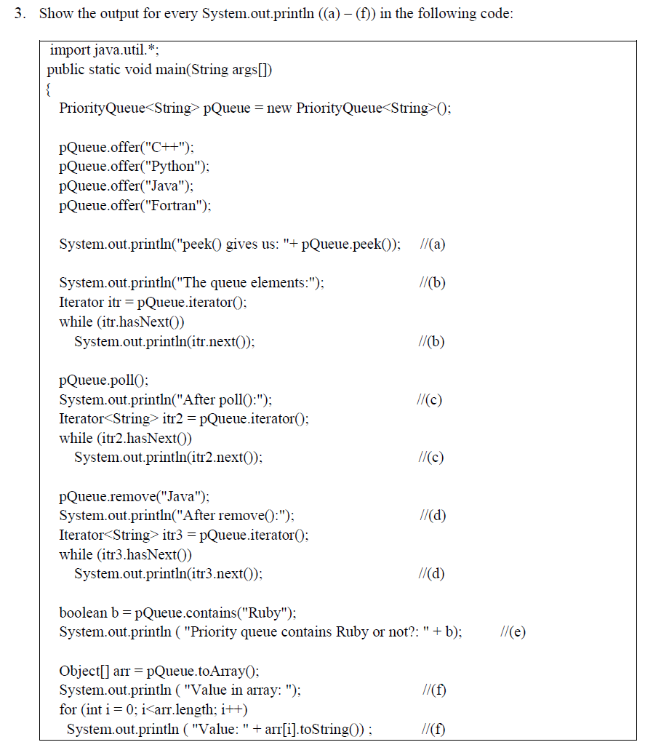
- peek() gives us: C++

The queue elements:
C++
Fortran
Java
Python

After poll():
Fortran
Python
Java

After remove():
Fortran
Python

- Priority queue contains Ruby or not?: false

Value in array:
Value: Fortran
Value: Python

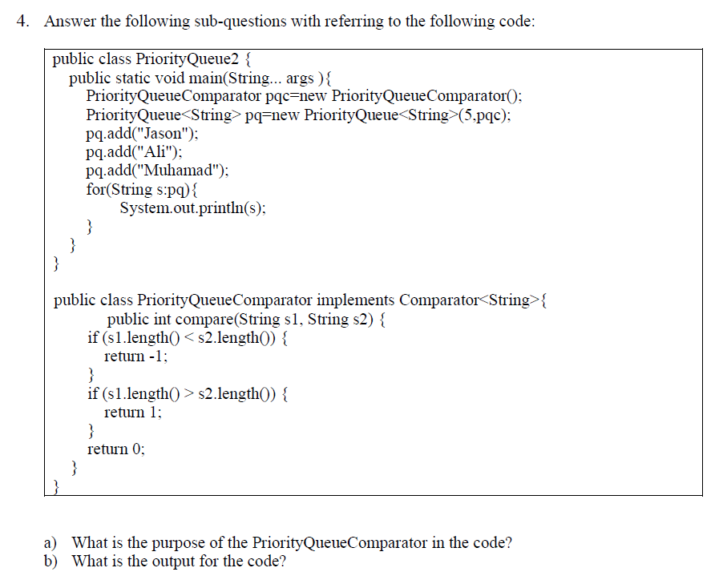

- Purpose of the PQC is to have control over how we rank our elements in the priority queue, in this case the shortest string has the highest priority over longer ones.

Ali
Jason
Muhamad

